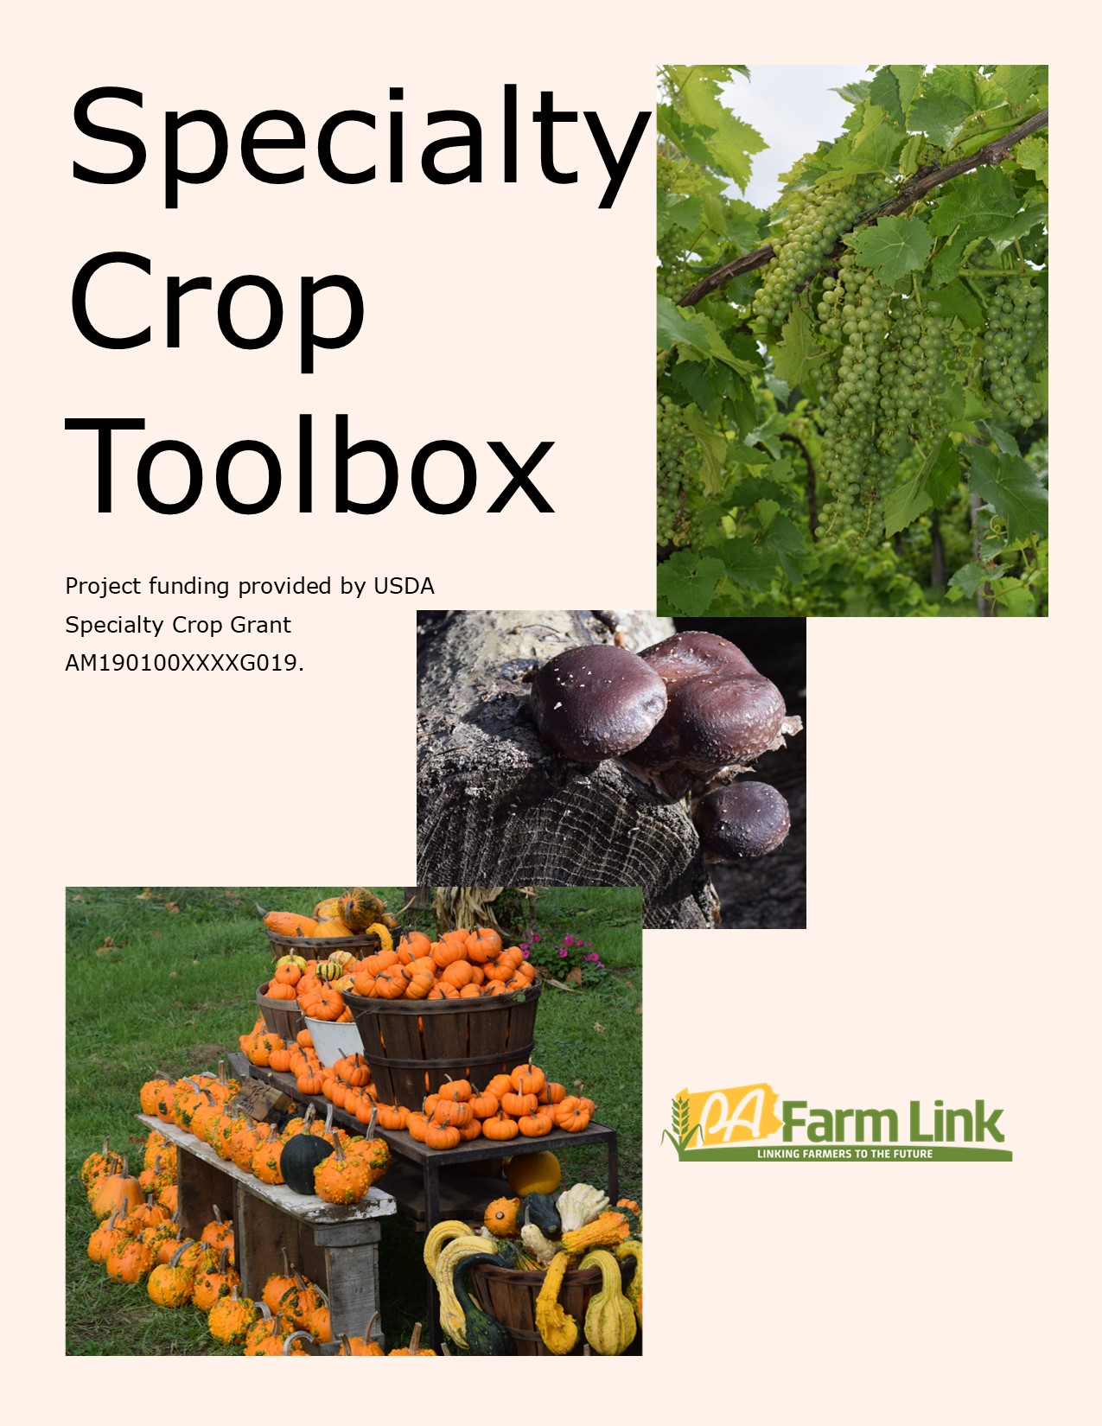

Wholesale Toolbox for Farmers

GAP/FSMA/Food Safety

Chesapeake Harvest- Provides resources, workshops & webinars, and free or low-cost One on One Coaching in food safety compliance, including writing Food Safety Plans. Their Food Safety Toolkits include templates that can be used to write your own Food Safety Plan
Resources - Chesapeake Harvest
11 South Harrison St, Easton, MD 21601
410-690-7348

Food Safety Modernization Act (FSMA) FSMA is a food safety regulation put in place by the FDA that all produce farmers must comply with unless you meet one of the exemptions. You can find more information on FSMA here:
FSMA Final Rule on Produce Safety | FDA
Food and Drug Administration
5001 Campus Drive
Wiley Building, HFS-009
Attn: FSMA Outreach
College Park, MD 20740

Penn State Center for Agricultural and Shale Law FSMA Guide on Legal/Regulatory/Compliance Issues
https://aglaw.psu.edu/research-by-topic/library-guide/fsma/?sc=Home
Brook Duer, Staff Attorney
814-865-4290
dhd5103@psu.edu

The Produce Safety Alliance is a collaboration of Cornell University, the FDA, and USDA, to help farmers achieve FSMA compliance. They offer training and resources.
Welcome to the Produce Safety Alliance website! | Produce Safety Alliance (cornell.edu)
Elizabeth A. Bihn, Ph.D.
PSA Director
Food Research Laboratory
665 W. North Street
Geneva, NY 14456
315-787–2625

Penn State Extension: Resources on Food safety and FSMA compliance
Farm Food Safety | Penn State Extension (psu.edu)
Jeff Stoltzfus, Extension Educator
717-283-2597
jhs3@psu.edu

Good Agricultural Practices (GAP) Certification is a voluntary food safety audit but is required by many wholesale buyers. You can find more information about GAP here:
Good Agricultural Practices (GAP) Audits | Agricultural Marketing Service (usda.gov)
717-787-4315

Penn State Extension GAP Resources & Training
Includes information on writing a Food Safety Plan, and training resources for farmers and workers. Features training videos and posters/literature in both English and Spanish.
https://extension.psu.edu/food-safety-and-quality/farm-food-safety/good-agricultural-practices
Jeff Stoltzfus, Extension Educator
717-283-2597
jhs3@psu.edu

Global Food Safety Initiative (GFSI) is an international food safety standard that is required by some larger wholesale buyers, especially those who purchase higher-risk products, such as greens and microgreens. More information on GFSI compliance can be found here:
Harmonisation - MyGFSI What is the SQF Program? - Safe Quality Food Institute (sqfi.com)
301-563-3383

UPC/PLU/GTIN Codes

The Produce Traceability Initiative (PTI) is an industry inititative to improve the traceability of products and a traceability plan is required for GAP certification and some wholesale buyers require it. The PTI uses Global Trade Item Numbers (GTIN) to achieve external traceability after the product leaves the farm. Find more information on the PTI here:
The Produce Traceability Initiative –
Liz Sertl
Director, Community Engagement
GS1 US
300 Charles Ewing Blvd
Ewing Township, NJ 08628
609-620-4608

To learn more about GTIN numbers, check out this resource:
GDSN Data Pool | Syndigo
141 W Jackson Blvd.
Suite 1220
Chicago, IL 60604
312.766.4801

Chesapeake Harvest- Traceability & Recall Toolkit
Traceabililty & Recall - Chesapeake Harvest
11 South Harrison St, Easton, MD 21601
410-690-7348

PLU-Some retailers require a “Produce Look Up” Sticker (PLU). PLU standard codes are assigned to each category of produce in the industry and code stickers can be purchased from packaging material vendors. You can learn more & browse the different codes for different produce items here:
PLU-codes (ifpsglobal.com)
PO Box 6036, Newark, Delaware 19714-6036, USA

GS1 barcodes are unique to your farm and are required by some larger grocery store chains for supply chain tracking. Apply for a GS1US barcode here:
GS1 US U.P.C.s, Barcodes, & Prefixes
937.435.3870

Liability Insurance/Legal Considerations

Penn State Center for Agricultural and Shale Law
Legal Planning for Specialty Crop Producers Resources & Webinars
https://aglaw.psu.edu/legal-planning-for-specialty-crop-producers-webinar-series/
Jackie Schweichler, Staff Attorney
814-746-4619
jks251@psu.edu

Should Farmers Market Vendors Carry Product Liability Insurance? | Food Safety News
1012 First Avenue
Fifth Floor
Seattle, Washington 98104-1008
913.205.3791

Cold Supply Chain/Produce Handling & Quality Control

Cold Supply Chain- Establishing a 100% Cold Supply Chain is important to maintain product quality and is a requirement of some wholesale buyers. Some buyers temp product upon receiving and may reject deliveries that do not meet their temperature standards.

The CoolBot is a less expensive alternative to installing a walk-in cooler for cold storage. It is important to remember that CoolBots are most effective when produce is already “cool” going into the cold storage (picked in the morning before it retains much field heat), and that CoolBot units may need replaced more often than commercial refrigeration options:
CoolBot provides inexpensive, effective cooling | Feed the Future Innovation Lab for Horticulture (ucdavis.edu)

Pack ‘N Cool Refrigerated Trailer: NC State University Plants for Human Health Institute developed a DIY mobile refrigerated trailer model that could be replicated by farmers using CoolBot technology. The instructions can be found here:
Pack ‘N Cool Construction Summary – Plants for Human Health Institute (ncsu.edu)
704-250-5400

Chesapeake Harvest- Post-Harvest Handling for Quality & Shelf-Life Toolkit
Post-Harvest Handling for Quality & Shelf-Life - Chesapeake Harvest
11 South Harrison St, Easton, MD 21601
410-690-7348

Palletizing/Packaging Industry Standards

Wholesale & Retail Product Specifications Guide: Published by NC Growing Together, contains wholesale & retail packaging standards, post-harvest handling best practices, and product quality standards to help you meet buyer standards
wholesale-and-retail-product-specs-2.pdf (ncsu.edu)
PO Box 7609, NCSU
Raleigh, NC 27695
919-513-0954

Wholesale Marketing

RangeMe is a marketing platform used by many larger wholesale buyers (including many grocery store chains) to connect with producers. Go to this link to create a profile and connect with potential buyers.
RangeMe
questions@rangeme.com

Selling at Produce Auctions: https://extension.psu.edu/9-tips-for-selling-and-succeeding-at-produce-auctions (article)
Penn State Extension
Becky Chalupa, Extension Educator
Office: 717-283-2598
bchalupa@psu.edu

The Packer-Industry information on market trends & news
Markets | The Packer

General Information

The Pennsylvania Association for Sustainable Agriculture has many resources on specialty crop production, marketing, and food handling and safety, including webinars, workshops, and online resources.
Resources - Pasa Sustainable Agriculture (pasafarming.org)
1631 N. Front St.
Harrisburg, PA 17102
814-349-9856

Penn State Extension: Information on specialty crop production
Forage and Food Crops - Penn State Extension (psu.edu)
877-345-0691

PA Vegetable Growers Association-information on marketing, specialty crop production, industry networking, etc. Holds a large annual educational conference.
Mid-Atlantic Fruit and Vegetable Convention | Pennsylvania Vegetable Growers Association (pvga.org)
815 Middle Rd
Richfield, PA 17086-9205
717-694-3596

NC State Extension Local Food Webpage includes resources on Food Hubs, Distributors, and Post-Harvest Handling & Food Safety
Distribution & Aggregation | NC State Extension (ncsu.edu)
Hannah Dankbar
Extension Local Food Program Manager
North Carolina Cooperative Extension
NC State University
Campus Box 7604
Raleigh, NC 27695
919-515-1195

Provided by:
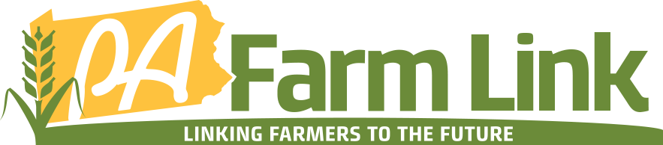
Providing the following resources for PA farmers:
- · Land Database
- · Succession Facilitation
- · Technical Resources
- · Workshops/Webinars
pafarmlink.org 717-705-2121 farmland@pafarmlink.org
With support from:
